Theme 6

Hall of Fame

Pupil Resource Sheet 1

Douglas Clark

Douglas Clark was born in Ellenborough, near Maryport in Cumberland on 2nd May 1891. He played rugby for Ellenborough National School. On leaving school his first job was to help his father, who was a coal merchant. Aged 14, Douglas was able to carry a hundredweight of coal under each arm, early evidence of his awesome strength.

Douglas joined amateur northern union club Brookland Rovers at the age of 15, and three years later, in 1909, Huddersfield paid £30 for him.

Douglas made his debut for Huddersfield on 25th September 1909 at Hull Kingston Rovers, the first of 485 matches which remains a Huddersfield club record.

His and Huddersfield’s first northern union trophy came just two months later when Batley were beaten 21-0 in the Yorkshire Cup Final. Ferocious in the tackle and a battering ram with the ball, Douglas was a key forward in a rapidly improving Huddersfield team. In 1911-12 they won the Yorkshire League and Cup and the Northern Union title, beating Wigan 13-5 in the championship final. Another highlight was a 21-7 win over the Australian tourists before 17,066 spectators at Fartown.

A cartoonist depicts how Douglas appeared to overpower his opponents

Douglas was also now a regular in the Cumberland county team that beat both Yorkshire and Lancashire in 1911.

Three more trophies came Huddersfield’s way in 1912-13 – the Yorkshire League, the Challenge Cup, when Huddersfield came from behind to beat Warrington 9-5 in the final, and the League Championship, Douglas scoring a hat-trick of tries as Wigan were beaten 29-2 in the final.

In 1913-14 this great Huddersfield side had to settle for just two trophies – the Yorkshire Cup and the Yorkshire League. Huddersfield were expected to make it three championships in a row, but were surprisingly beaten 5-3 in the final by Salford at Headingley.

Then came the season for which The Team of all Talents is remembered, 1914-15. War had been declared on Germany in August 1914, but the rugby and football seasons went ahead as the war was expected ‘to be over by Christmas’. No-one had any idea how long and dreadful it would be.

As casualties began to return from the front, Huddersfield’s northern union team helped to keep spirits up in the town.

The Yorkshire Cup was retained with a 31-0 defeat of Hull in the final. The Yorkshire League followed. Douglas scored a try as Leeds were beaten 35-2 in the Championship Final, leaving just the Challenge Cup Final against St Helens. Huddersfield won another one-sided match 37-3, becoming only the second team, after Hunslet in 1908, to win all four trophies in one season. Only Swinton, in 1928, have done so since.

By this time, Douglas’s international career, which began with an 11-11 draw against Australasia at Edinburgh in 1911, was well underway.
His most famous Test Match came at Sydney in July 1914. The British team held out to win 14-6, despite having only ten men to Australia’s 13 for large periods of the second half, and at one point only nine. Douglas broke his thumb in the first half and dislocated his collar bone just after half time. No substitutes were allowed in those days so, despite the pain, Douglas was strapped up and twice returned to the field, but found it was impossible to continue. He left the pitch for the final time in tears. This match is known as the Rorke’s Drift Test, after the famous Boer War battle of 1879 in which 150 British troops defended their garrison against over 3000 Zulu Warriors.

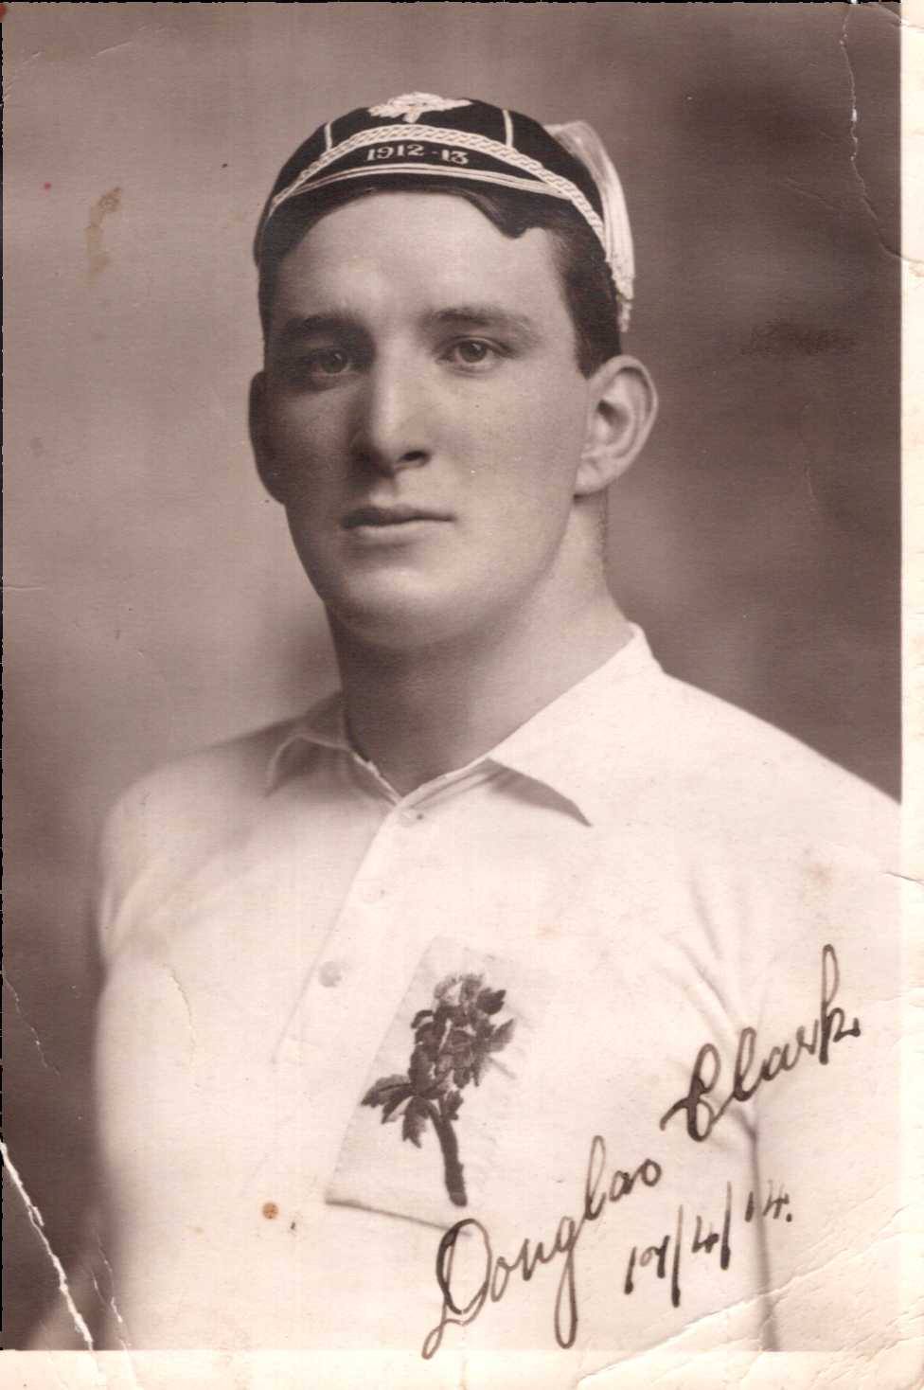
Douglas in his Great Britain shirt and cap

Douglas and the great Huddersfield Team of all Talents were at their peak when war intervened. They would not play together again for four years.

Douglas was one of several players to join the Army Service Corps. Whilst training, he played rugby union for the famous and successful Grove Park team alongside his Huddersfield team mates Harold Wagstaff, Ben Gronow and Albert Rosenfeld.

Fighting in the fiercest battles of 1917, Douglas was twice gassed during the Battle of Messines and was carried from the battlefield with 18 shrapnel wounds during the Battle of Passchendaele. Discharged from the army in a wheelchair with a 90% disability certificate, Douglas was awarded the Military Medal for bravery. He voluntarily rejoined his unit in 1918.

Doctors advised him to retire from rugby for his own safety, but in 1919-20 Douglas helped Huddersfield to three more trophies – the Yorkshire League and Cup and the Challenge Cup. Another four trophies seemed certain, but Hull won the Championship final 3-2 against a Huddersfield team without five players who were sailing with the Great Britain team to Australia. One of these five was Douglas.

He played in all six Test Matches on the tour and scored the match-winning try in Wellington as Great Britain came from 10-0 down to beat New Zealand 11-10.

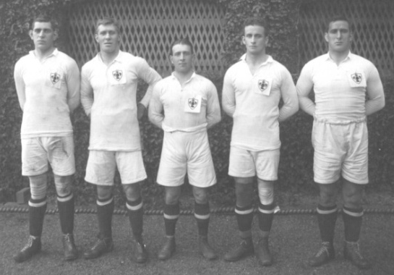
Huddersfield’s 1920 Lions tourists:
Ben Gronow; Harold Wagstaff; Johnny Rogers; Gwynne Thomas; Douglas Clark

Douglas captained Huddersfield in his later seasons and played his last game for the club in February 1929. This wasn’t quite the end, for in the following December Cumberland called him out of retirement, aged 38, to captain them against the Australian tourists. It was a fitting end to a great career when Cumberland won 8-5.

Douglas Clark

Douglas’s sporting life was, however, far from over as he continued his other sport of wrestling. He had won his first wrestling championship in Cumberland at the age of 15 and wrestled at the highest level for over 30 years. He was the champion wrestler of the British Army in the First World War, and won the belt for All-in Wrestling Champion of the World outright in 1930. He toured Australia in 1934 and 1936 and those who saw him action were convinced he was the ‘strongest man on the planet’. He eventually retired from wrestling at the age of fifty in 1941.

Despite his sporting heroics, Douglas continued to work as a coal merchant in Huddersfield. In later life he was a member of Outlane and Huddersfield Golf Clubs and served on the Huddersfield Rugby League club’s committee. He also loved fishing.

He continued to keep himself fit by running and swimming, and it was a great shock when he died suddenly at his Birkby home on 1st February 1951, aged 59, when a bad dose of influenza turned to pneumonia. Throughout his life he had returned regularly to the Cumberland coast to see his childhood friends and he is buried there in his home town, Maryport.

Douglas’s great talent was recognised when he was inducted into the Huddersfield Rugby League Hall of Fame in 1999, and by the game of rugby league when he was inducted into the Rugby League Hall of Fame in 2005.
Douglas Clark: Playing Record
Team | Matches | Tries | Goals | Points
Huddersfield | 485 | 99 | 0 | 297
Lions (Tests) | 11 | 3 | 0 | 9
England | 6 | 5 | 0 | 15
Cumberland | 31 | 3 | 0 | 9
Other | 1 | 0 | 0 | 0
Totals | 534 | 110 | 0 | 330

Huddersfield NURFC 1914-15
Back: A Lee; JW Higson; H Banks; E Jones; E Heyes; F Longstaff; D Clark; A Swinden
Middle: A Bennett (trainer); R Habron; M Holland; S Moorhouse; H Wagstaff (captain); T Gleeson; G Todd; B Gronow; H Bennett (assistant trainer)
Front: Yorkshire League Cup; WH Ganley; Northern Rugby League Cup; AA Rosenfeld; Northern Union Challenge Cup; JH Rogers; Yorkshire Challenge Cup

